# 

# About Seville:

*“Séville seule à posséder plusieurs don Juans; mainte autre ville cite le sien.”*

# Biography:

Prosper Mérimée was an author who comes from a rich and artistic background. He did some studies in right before starting to be interested in literature.

It was in 1825 that he began publishing texts, particularly short stories, that would make him known and earn him an election to the French Academy in 1844.

Mérimée made two trips to Spain, one in 1830 to meet the future Earl of Mojito and another in 1853

One of his most memorable works is Carmen, which will inspire the creation of many monuments, including Carmen's opera and Carmen in front of the Seville arenas.

# Carmen

His bibliographical research and his memories of his travels will feed this short story that is Carmen, which symbolizes his destructive passion for Spain.

# Pierre-Léonce Imbert:

# About Seville:

*“Nous voici donc revenus à Séville, cité charmante bâtie par Hercule dans une atmosphère embaumée.”*

# Biography:

Pierre-Léonce Imbert was a journalist born in Castang in the Dordogne in the 19th century.

He has written many works including "L'Espagne, splendeurs et misères”.

# L'Espagne, splendeurs et misères

This book is part of a policy of heritage conservation of French literary works set up with the BNF (Bibliothèque nationale de France).

It was published in 1875. It contains works related to Spain and Seville in particular (pages 87 - 92). In it, the author describes the experiences he had while visiting the heritage of Seville.

# 

# Théophile gautier

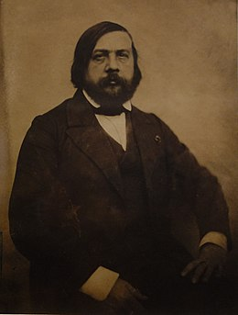

# About Seville:

*“Sur le Guadalquivir, en sortant de Séville,*

*Quand l'oeil à l'horizon se tourne avec regret,*

*Les dômes, les clochers font comme une forêt :*

*À chaque tour de roue il surgit une aiguille.”*

# Biography:

Jules Pierre Théophile Gautier, born at Tarben the 30 august 1811 and died at Neuilly-sur-Seine the 23 october 1872 was a poete, a novelist and and a french art critic.

He started to publish his first poems between 1831 and 1832.

In 1840, with Eugene Piot he started to travel around spain, a country he only knew through the “Contes d’Espagne et d’Italie” from Alfred and “les Orientales” from Victor Hugo

From his experiences, he wrote “Voyage en Espagne” a kind of carnet which describe the sensation he had during his journey.

# Perspective

Perspective was on of his many poems written between may and october 1840 during his journey in Spain.

It describes Seville’s landscape and it severals monuments.

# Ednat Quinet

# 

# <p><b>About Seville :</b>

*“Je me suis donner le plaisir à Séville de monter ces beaux chevaux andalous et de faire de longues courses dans les environs.”</p><p>*

# <b>Biography :</b>

Jean-Louis Edgar Quinet, born at Bourg-en-Bresse the 17 february 1803 and decreased the 27 march 1875, was a historian,poete,philosoph, and a french politican, republicain et anticlerical.

Attracted to literature, Edgar Quinet released his first book which was “Les Tablettes du juif errant” in 1823.

He travelled a lot during his life.</p>*<p>*

# <b>Correspondance à sa mère :</b>

"Edgar Quinet gives to his mother the best of him."

Thus in 1877 are published in a book his private letters for his mother. In his letters, he describes his travels, including those to Spain.

He will describe his feeling of the landscape and the monuments that were there.</p>

# Victor Hugo

# 

# <p><b>About Seville :</b>

*"Toutes ces villes d'Espagne*

*S'étendent dans la campagne*

*Ou hérissent la sierra ; "</p><p>*

# <b>Biography :</b>

Victor Hugo was a French poet, playwright and romantic prose writer, born on 26 February 1802 in Besançon and died on 22 May 1885 in Paris. He was considered as one of the most important French-speaking writers. He was also a political figure and a committed intellectual who played a major role in the history of the 19th century.

Victor Hugo occupies a prominent place in the history of French literature in the 19th century, in genres and fields of remarkable variety.</p><p>

# <b>Les orientales “Grenade” :</b>

Granada is one of the many poems in the "Orientale" collection written by Victor Hugo.</p>

# Alexandre Dumas

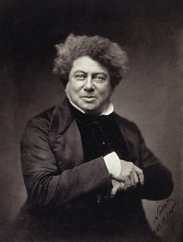

# <p><b>About Seville :</b>

*“Demain, je vous parlerai de la perle de l'Andalousie.”</p><p>*

# <b>Biography :</b>

Alexandre Dumas (also known as Alexandre Dumas père (French for father)) was a french writer born on 24 July 1802 in Villers-Cotterêts (Aisne) and died on 5 December 1870 in the hamlet of Puys, a former commune of Neuville-lès-Dieppe, now part of Dieppe (Seine-Maritime).

It was in 1840 that he began his first trip to Spain.</p>

# <b>Lettres choisies :</b>

In 1846, A. Dumas went to Spain for the marriage of the Spanish infanta and the Duke of Montpensier. He and his group of friends followed a route that took him from Paris to Cadiz and visited Andalusia. He was seduced by the Seville dancers and thus took the reader to the show and the ball for a festive trip.</p>

# 

# POITOU Eugène

# <p><b>About Seville :</b>

*“Il est difficile d'imaginer rien de plus merveilleux que cet Alcazar.”</p>*

# <p><b>Biography :</b>

Eugène Poitou was a magistrate and literary critic who lived during the 19th century.</p>

# <p><b>Voyage en Espagne :</b>

“Voyage en Espagne” is a book written by Poitou Eugène and illustrated by V. Foulquier where he describes his journey.</p>

# 

# Voltaire

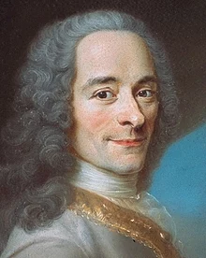

# <p><b>About Seville :</b>

*La cour était à Séville, les galions étaient arrivés, tout respirait l'abondance et la joie dans la plus belle saison de l'année.</p><p>*

# <b>Biography :</b>

François-Marie Arouet, known as Voltaire, born on 21 November 1694 in Paris, the city where he died on 30 May 1778 (at the age of 83), was a French writer and philosopher who marked the 18th century and occupies a special place in the French and international collective memory.

After studying rhetoric and philosophy with the Jesuits, as well as law, François Marie Arouet, known as Voltaire, opted for a literary career.</p><p>

# <b>Scarmentado :</b>

The History of Scarmentado's Travels is a philosophical tale by Voltaire written around 1753.

This ironic tale takes us to various countries in Europe, Asia and Africa and refers to America, through the character of Scarmentado, whose name comes from the Spanish word "escarmentado" which means "learned by experience".</p>